Let Us In:

Under what conditions can art empower the working class, given that the elite consume the art world?

Jessica Thomas

BA(Hons) Fine Art

10th January 2017

Illustrations

Figure 1: Photographed by Prudence Cuming Associates © Damien Hirst and Science Ltd. All rights reserved, DACS 2012…………………………………………… pg. 8
Figure 2: How The New Museum Committed Suicide with Banality, William
Powhida,
http://www.postmastersart.com/artists/william_powhida/powhida_numu.html………………………………………………………………………………………………………..pg. 11
Figure 3: Sechs Menschen, die für das Sitzen in Pappkartons nicht bezahlt werden
dürfen (Six People Who Are not Allowed to Be Paid for Sitting in Cardboard
Boxes, 2000), Santiago Sierra, 2000. Available at:
https://frieze.com/article/santiago-sierra…...........................................................pg. 13
Figure 4: Untitled 1992/1995 (Free/Still), Rirkrit Tiravanija…………………………pg. 17
Figure 5: Rirkrit Tiravanija’s, FEAR EATS THE SOUL, Gavin Brown’s enterprise, New
York 2011, art agenda, MEDIA FARZIN……………………………………………………pg. 9
Figure 6: Feed Me (film still), Rachel Maclean, 2015, Courtesy the artist and Film and
Video Umbrella…………………………………………………………………………………….pg. 21
Figure 7: Installation view: British Art Show 8, Leeds Art Gallery, 2015-17. Photo ©
Jonte Wilde Photography 2015……………………………………………………………...pg. 21
Figure 8: Rowing (2017) Rachel Maclean, ‘Please, Sir...’ Short edit with credits, 2014.
Available at: https://vimeo.com/111104632 ………………………………………..pg. 25

Many artists create work intending to draw attention to social and economic issues that occur globally. Through their art, they try to generate interest in and conversation around their chosen subject, in the hope that it may effect positive change upon the current system, and by extension the lives of those who live under it. Is this possible to achieve when progressive change that benefits the mass of people, rarely originates from the ruling elite without significant pressure from below? Artists may have the intention of empowering working class people; by offering critical perspectives on contemporary issues and using their platform to garner greater awareness, but are the intended audience to be found in art galleries? If so, do they understand the art work when considering contemporary art has pushed the boundaries of the medium, creating an ever more abstract versions of concepts?

Artist such as, Francis Alyis, Pierre Huyghe, Santiago Sierra and Louise Lawer have successful careers focusing their work on social issues such as race and gender inequality and wealth distribution, I will focus upon two artist: Rirkrit Tiravanija and Rachel Maclean, as both artists are known for creating publicly engaged works, yet they both approach it through very different means. Whilst Tiravanija’s work directly involves the participation of the audience, to the extent that he lists “lots of people” within his materials (Bishop, 2004, pg. 56). Whilst Maclean’s method of public engagement arises, and is stimulated through cinematic understanding, as a way to construct a narrative within her work that is understandable to a wider audience. To gather a greater understanding of how these works are received by the public I will look into the texts of Claire Bishop, as she debates the role of “socially engaged art” (Bishop, 2006, pg.1) within society, questioning where the line that can be drawn between contemporary art and a community project. Drawing reference from historical texts on work ethics and labour rights within the UK, I will draw a conclusion on whether I believe the old Marxist/socialist ideal of worker ownership of the means of production can be achieved though inspiring the working class through contemporary art.

I will begin by looking into what is meant by class terminology through working class history. Starting with writer Robert Tressell, Pen name of Robert Noonan 1870-1911, an Irish decorator who arrived in England in 1901, in his semi-fictional writing The Ragged Trousered Philanthropists (Published In 1914, 3 years after Noonan’s death in 1911), as a means to understand the working class’s lack of self-confidence in their political autonomy in and therefore an unwillingness to change the surrounding systems, which allows poverty to take place within our society. The main character Owen (one presumes modelled on Noonan himself) has a deep contempt with the social and working conditions that he and his fellow employees are forced to deal with. Owen’s discontent is informed by a Marxist view on how society should be ran, a society where all within it can “secure for themselves all the benefits of civilization; the necessaries, comforts, pleasures and reginments of life, leisure, books, theatres, pictures, music, holidays, travel, good and beautiful homes, good clothes, good and pleasant food” (Tressell, 2005, pg. 17). If those who work can collectively produce all the luxuries of life then on an individual level “we should have full share of the things that are made by work” (Tressell, 2005, pg. 17) as they have played a role in societies creation. Yet many of the working class within this novel, and still today despite also being dissatisfied with the conditions of the work place, wages, and the constant rising costs of living, they can not see how the system it’s self is whom to blame, and not the certain elements that are necessary factors of these systems. As with major political debates today, many characters in the book are distracted from the cause of their poverty, with arguments blaming poverty on issues like “over-population” (Tressell, 2005 pg. 13) in England despite that there are still today “thousands of acres of uncultivated land” (Tressell, 2005 pg. 13). This issue is relevant today still with many people voting to leave in the European Union referendum due to concerns over open borders causing uncontrolled migration workers taking up jobs, school places and hospital beds, in the hope that it would create jobs for those who where born in the United Kingdom and relieve pressure on other services.

Over the century since The Ragged Trousered Philanthropists was first published the condition of the working class has improved significantly, the pace of social change being pushed on by 2 World Wars, where the sacrifices of working class people and their increased ability to manifest political will through the formation of the Trade Union funded Labour Party lead to the creation of the NHS and the wider welfare state. The nature of class has changed along with the times. The export of much traditional manufacturing business abroad, the privatisation of most nationalised assets, the closure of heavy industry like coal mines conducted in concert with attacks on trade union rights and a reliance on laissez-faire free market solutions to jobs, housing and finance in the last two decades of the century served to shatter the traditional class ties and definitions.

Though commonly both today and historically the working class may be viewed as those who work with their hands in manual positions, the rise of technology and shifts in labour markets combined with inflated housing, food, and transport costs have lead to the erosion of real earning power for traditionally middle class roles, teachers, office workers etc. For the purpose of this essay we will take the working class to mean all those reliant on their ability to sell their labour to fund their existence. Those who own assets that provide them with income are not reliant on their labour and are therefore the elite

The people whom purchase contemporary art often do so at lavish art exhibition openings that are often only open to those who the curator knows to be collectors or critics. Alternatively, exclusive art fairs such as the London Art Fair with its fifteen thousand pounds a day entry fee; provide an environment where “priceless” (Thompson, 2016) pieces of work can be purchased for a “hefty price tag” (Thompson, 2016). This is the venue where a Damien Hirst piece Beautiful Inside My Head Forever sold for £161 million in 2008, which is one of the largest price tags obtained in the history of the show. When juxtaposed against the fact that that the Trussell Trust distributed 1,109,309 three day emergency food packs through their 424 food banks across the United Kingdom in 2016 (Foodbank use remains at record high, 2016), at such a large amount of money could be spent by one person on an art piece appears immoral. With this being around the amount of money needed to purchase the works, it is no surprise that individuals from working class backgrounds feel intimidated by going into gallery space if the work is not meant for them to buy, why is it meant for them to view? Art is popular amongst different types of people from many different types of backgrounds, the Tate Britain alone seeing 5.1 million visitors in 2015 and the same year had the “highest number of visits by young people from any art museum in the world, with over 3.5 million under the age of thiry-five” (Tate annual report 2014/ 2015). Despite this “many people are quite insecure around galleries” (Perry, 2013) with the fear of not understanding the world even when a written text is provided as “the language” (Perry, 2013) used is often impossible to decipher, even to those intimately involved in the art world.

Artist, William Powhida made a daring critic oh how galleries are owned and operated with his 2009 piece How the New Museum Committed Suicide with Banality (fig.2) was shown in New Museum in Brooklyn. In this work Powhida did not only passed comments on the types of workers that get into the gallery, but also the individuals that are considered instrumentally involved in the art world. Works like the show that even the artists think the sense of seriousness in the art world is
exaggerated.
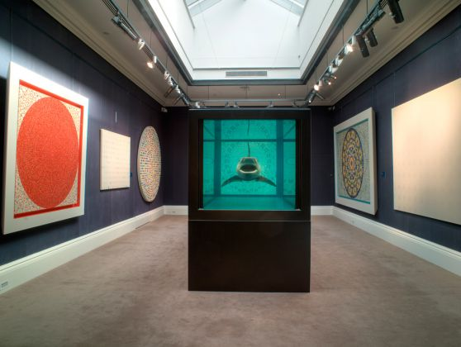

Figure 1 Damien Hirst, Beautiful Inside My Head Forever, Sotheby’s London exhibition, 2008

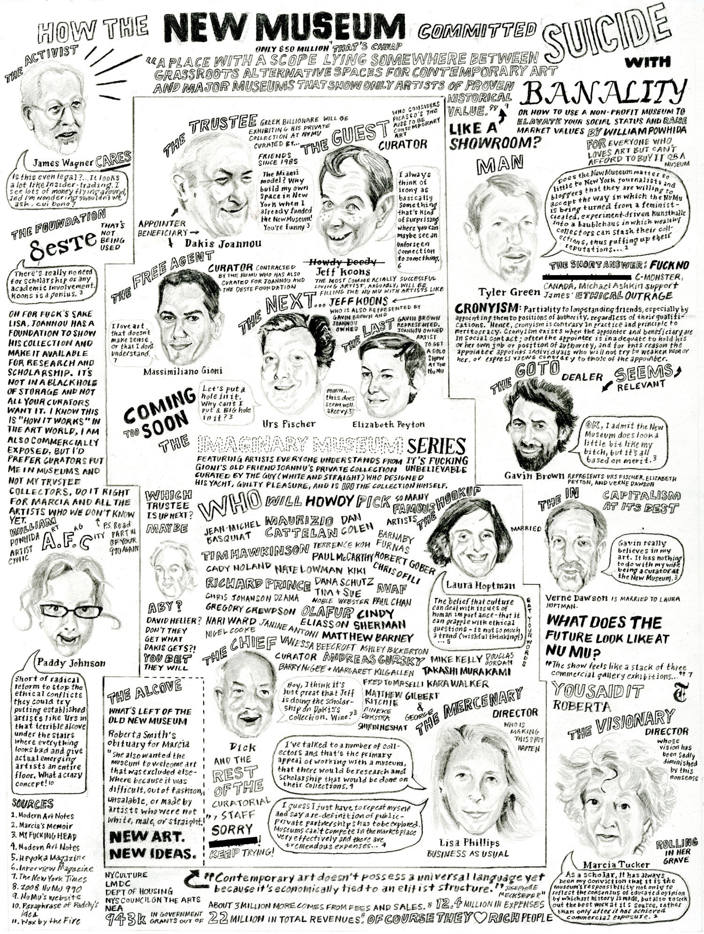

Figure 2 William Powhida, How The New Museum Committed Suicide with Banality, 2009

Some academics may argue that when artists directly bring these issues into the gallery space, such as the work by controversial artist Santiago Sierra, it simply out rages the public towards him and therefore does not inspire change. To focus on one piece in particular to help discuss the issue, his 2000 work shown in Germany titled, Sechs Menschen, die für das Sitzen in Pappkartons nicht bezahlt werden dürfen (Six People Who Are not Allowed to Be Paid for Sitting in Cardboard Boxes, 2000) (fig. 3), in which, as the name suggests individual boxes held six people that are seeking asylum in Germany, in which the law “forbids” (Heidenreich, 2001) them from receiving payment for their work by the artist. Visitors uncomfortably walked around the now “strange, oppressive atmosphere” (Heidenreich, 2001) that the gallery space had aquired, forced to notice the people that usually get little to no attention. This work draws to attention issue of labour in a way that the audience have to directly see and hear the unpaid or lowly paid workers that hold up the society that that audience is a part of. Although Kimberlé Crenshaw, discrimination lawyer suggests that “when we can’t see a problem, we can’t solve it” (TED, 2016) however simply shedding light on any given issue cannot solve it either, if we believe in the theory that change becomes from below, to inspire change art must not only be informative it must be capable of moving perspective. Grant Kester in response to Claire Bishop’s text on the socially engaged art world, Another Turn, Artform, May 2006 argues that the:

Historical identification of critical theory with the act of revealing the (structural) determinates that pattern our perception of reality, the paranoid approach obsessively repeats the gesture of “unveiling hidden violence” to a benumbed or disbelieving world. As enabling and necessary as it is to probe beneath the surface of appearance and to identify unacknowledged forms of power. (Kester, 2006).

Confronting the viewer with the issue directly in the manner of Sierra, both does and does not encourage social change depending on your stance. I believe that revealing an issue to a wider audience, in this case the plight of illegal migrant workers, in a thought provoking manner it can have the power to direct and shape social consciousness, however the shock value of a work combined with the limited reach and narrow demographics of gallery spaces can serve to limit this effect.

Figure 3 Santiago Sierra, Six People Who Are not allowed to be Paid For Sitting in Cardboard Boxes, 2000, gallery floor space

Other artists such as Rirkrit Tiravanija are “best known for hybrid installations/ performances” (Bishop, pg.56) with the use of public involvement being a direct element in the creation of his work. Tiravanija’s works also seek progressive social change by installations that function as centres for community-based events. In an attempted to create a space for ideas to be exchanged and to blossom his 2011/12 installation, Untitled (free/still) (fig. 4) in the New York Museum of Modern Art (MoMA) where he served “piping-hot Thai green curry” (Allen, 2011 pg. 1) to the public for three hours per day. Tiravanija explained to the art critic Raimar Stange, in an interview via email that he “was trying to reanimate objects (from ready mades to pre-ready mades) by reintroducing their function” (Quarterly, 2015) this was informed by the fact that within Tirivanjia’s native Thai culture they have “neither subject nor object” (Quarterly, 2015) free from this dichotmomy, Tirivanjia’s work aims to focus on the experience of the audience and their relationship to each other and the space.

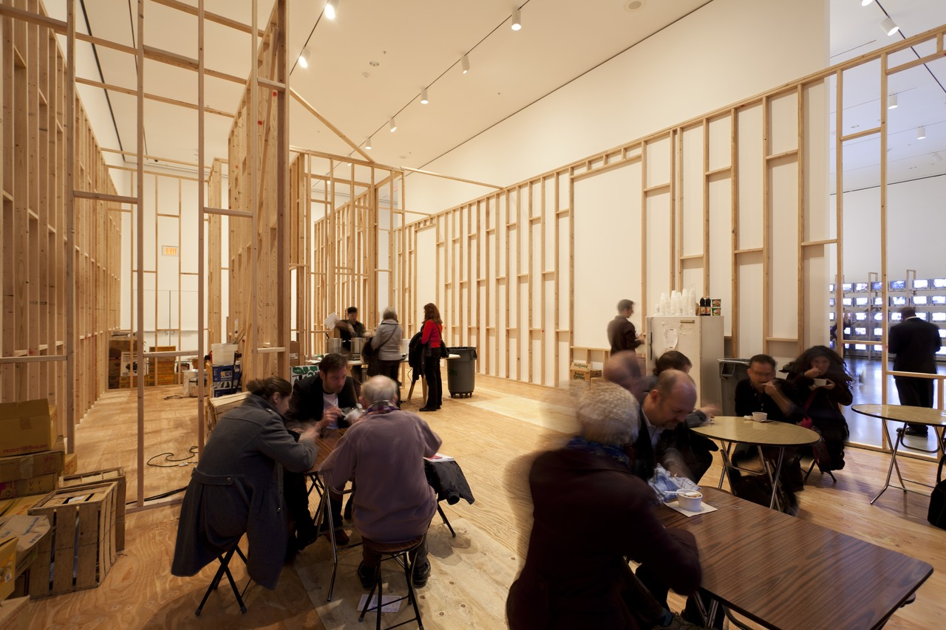

Figure 4 Rirkrit Tiravanija, Untitled (free/still), 2011/2012, Museum of Modern Art gallery floor

Although the food was not prepared on the gallery floor that, according to art critic, Jerry Saltz, gave his 1992 configuration a feel of being a “makeshift refugee kitchen” (Bishop, 2006, pg. 56) This informal, appreciably cheap assembly created a comfortable energy, with the use of pop up furniture and plastic cutlery used intentionally to help bring the gallery down from an elitist space to something that was less intimidating. Despite all the elements of the work combining within the room, helping to soften the surroundings, there is still question of whether the work achieved the goal of bringing the people together for social change. In the work “food is but a means to allow a convivial relationship” (Bishop, 2006, pg. 56) using a practice common to all cultures to bridge the gaps not only “between institutional and social space, but between artist and viewer” (Bishop, 2006, pg. 56).Given that this was the explicit aim, one would want a range of different audience members to come to share experiences. The intention of bringing people together over food to have conversations on social change is a noble one, yet whether this is the reality is somewhat questionable. To begin to understand whether this environment is changing the cultural elements of our class system we must first look into who goes to these galleries.

The MoMA is not a free entry gallery space, charging an entry fee of $24 dollars per person, with the exception being 4 hours on a Friday between 4pm-8pm during which time the gallery opens it’s doors to the public for free. This is a laudable policy however unless you happen to know this from being within the art world loop, or have the good fortune to visit on Friday afternoon there is little chance for you too find this out as it is not clearly promoted on their websites. Curator Richard Hylto believes that “art should be for the benefit of the community, as a means of instigating social worth and change” (Hylton, 1996, Pg. 4) but if the art is only accessible to a small number of people that can afford to spend time and money on galleries then the likelihood of it creating cultural change becomes ever more inconceivable.

The room was filled with “European tourists and other museum-going types, who spoke in hushed tones and photographed one another with smartphones” (Allen, 2011) which for me, at least in the particular setting of the MoMA , makes the work unsuccessful in achieving a bridge between all types of individuals, Emma Allen, arts and culture writer, described the whole endeavor as a “sacred soup kitchen for the middle-to-upper class” (Allen, 2011). French philosopher Jacques Ranciére has observed that “the productive contradiction of art’s relationship to social change, characterized precisely that tension between faith in art’s autonomy and belief in art as inextricably bound to the promise of a better world to come” (Bishop, 2006, pg. 7) and furthermore he believes that “the aesthetic doesn’t need to be sacrificed at the alter of social change” (Bishop, 2006, pg. 7).

Another of Tiravanija’s works FEAR EATS THE SOUL (fig. 5) took place in a New York gallery where the windows and doors had been removed from the entrance of the main exhibition space, exposing the interior of the gallery to the street. The title of the work FEAR EATS THE SOUL is daubed in thick black letters across the walls of what otherwise looks like an empty room. Constructed from wooden boards is a make shift factory/shop “where political slogans collected by the artist can be “hand-screened while you wait” by Nick Paparone, a student of Tiravanija, at $20 each” (Brown, 2011). This experience created an uncomfortable exchange between Paparone, selling the t-shirt and the customer, as the conversation is unavoidably focused around the art, instead of the usual encounter with the cashier when purchasing an item. Yet this work despite having no physical barriers at the point of entry, is still exclusive. Tiravanija states that the experience being created through interaction with the t-shirt vendor is the sole aspect of this work he and by doing so he is limiting the full experience to those who are able to afford to purchase a very hip political t-shirt that bear slogans such as “NOBODY KNOWS I AM A LESBIAN” and “I AM BUSY”. The roughness of the gallery space is intended to appeal to the audience, brooms are left out, the glass doors which previously hung in the entrance where removed and left against one of the walls, this aspect of the work reflects the banal mundanity of everyday life, in contrast to the pop-up tee shirt making shop that with it’s minimalist appearance gave off a very clean and edgy energy.

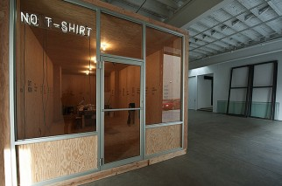

Figure 5 Rirkrit Tiravanija, FEAR EATS THE SOUL, Gavin Brown's enterprise, New York, 2011

Artist like those previously discussed can be seen to have forgotten the value of the aesthetic in the pursuit of creating work with a social stance, aiming through their work to instigate social or political change. In some regards by doing so they have made the work inaccessible to the working class by either displaying work in an envioroment that is not accessible culturally and finaccially. Perhaps artists seeking to trigger social progress could be more successful in this aim if they begin utilising more accessible pop culture imagery in their visual work and start to take advantage of new technology to aid in the distribution of their work to a wider, more global.

This type of visual explosion happens in works created by Scottish artist Rachel Maclean in which she creates fantasy worlds, made up of bright colours that are supersaturated, utilizing dystopian cyborg and pop culture elements to depict the future of our society if collectively we continue with capitalistic value systems. In her work she reviews poverty wealth, gender and the digital age, through her characters and story lines but for this instance I will focus on her piece that has been showing around the United Kingdom with the British Art Show 8, 20016/17 titled Feed Me (fig.6/ fig.7). The title comes from the need we share as capitalist consumers to consume, a need that we are encouraged through advertising to feel like we cannot fully satiate, this playful interrogation raises questions about the items we consume, and why we consume them. There is a running theme throughout the work where positivity oozes from every element of the characters being, with characters repeatedly uttering lines like “too happy” and “110 per cent” to describe every aspect of their being. Once this overwhelming positivity has been built up it reaches it’s crescendo, and the mood of the piece seems to flip to being unhappy, in which the characters use their positive speech to cover up their real emotions which, mixed with the characters never ending need for fulfillment creates an uncomfortable situation that Maclean describes as “nauseatingly positive and cheerfully grotesque” (British Art Show 8, no date).

One uncomfortable element of Mclean’s work is that all of the costumes and props are ready made items brought from children toy stores, pound shops and online websites, as “these monsters may look alien but in fact already exist, in various disassembled forms” (here and news, 2015) that is to say they have already been created within our “cultural imagination” (here and news, 2015). These concoctions of pre-existing costume elements combined with the use of harsh media propagated stereotypes helps to create a narrative that is intuitively accessibly to everyone. Depicting a vision of the future that seems possible with the use of items that have been designed and manufactured for use in our present society creates an uncanny sense that the situations and stories Maclean tells could happen in the near future.

Maclean’s work reflects the society we all create back to those who help create it, a reflection where you are able to see aspects of yourself within the some or all of the characters forcing the viewer to review their own place within society which helps to tackle the idea currently being sold by politicians and the press that the poorest and most vulnerable within the society are to blame for their “circumstances” (Todd, 2015, pg.362). Maclean’s work helps depict the conditions and contradictions of our society, one “where profit now clearly come before the peoples welfare” (Todd, 2015, pg.362) when welfare no long matters to those of power, living and working conditions for those without the power begin to disintegrate. For the system to continue there has to a sense that we are moving forward, stimulated by the false idea that happiness can be achieved by purchasing the right items.

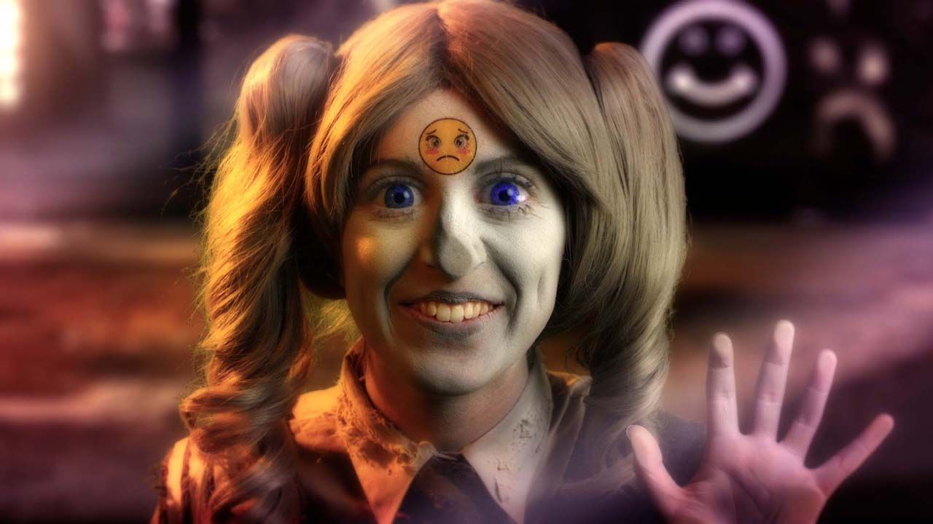

Figure 6 Rachel Maclean, screen still from video piece Feed Me, 2016/2017

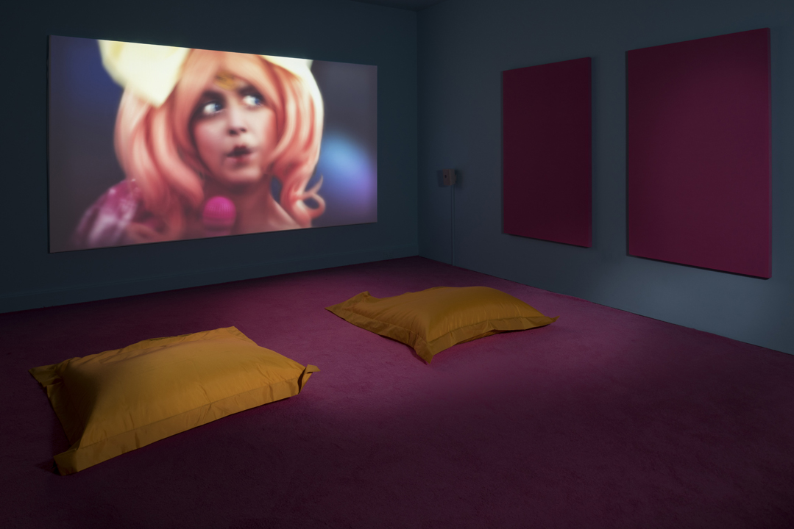

Figure 7 Rachel Maclean, installation shot of Feed Me, 2016/ 2017, Leeds, Britsh Art Show 8

In another of Maclean’s works entitled Please, Sir… (2014) scenes that appear to show two different worlds, are shown on a split screen. The first scene one is dark and derelict with recognizably English objects such as the ubiquitous red telephone box and the X Factor ‘X’ hidden amongst half torn down buildings. The other scene in contrast displays a great wealth depicted in this instance through McLean’s use of a clean pink background and extravagant throne imagery. Maclean makes use sound from a talent competition in which a young boy sings “Consider Yourself” from the 1948 Oliver Twist musical, to a King and Queen perched on their thrones. At first the royals speak fondly of the young boy, appearing to admire the boys talent and charm. This lasts until the King’s character discovers a ten pound note missing from his pocket, the audio then switches to a a reality TV show called ‘Jeremy Kyle’. In this show people, usually from working class backgrounds, sort out problems in their lives with the ‘help’ of th e host Jeremy Kyle. They argue over out of control individuals or unknown fathers to children, but in this particular episode the individual on the show got caught mugging a smartly dressed businessman and was being made out by Kyle to be the worst type of person. Maclean uses examples like this to further explore themes of “class and dependence within a cultural rhetoric of austerity and aspiration”,(PRO, 2017) as this individual suddenly becomes someone through media outlets, but is depicted as a villain. Although I agree that mugging a person is deplorable behaviour, we can not and should not assume that this means the individual concerned is all bad and when we consider his economic background we can understand that these actions do not stem entirely from choice, they come from a need. As previously discussed this shouldn’t be viewed in isolation. The mans criminal behaviour was not the root of his criminality. The criminal behaviour is a symptom of how we arrange our economic affairs. We can later come to an understanding that it is not “simply want more money: they wanted the power to shape their circumstances into ones in which they could find fulfillment” (Todd, 2015, pg.363) so demonising people for their seeking wealth in situations that seem immoral ignores the underlying reasons that compel people to act in anti-social ways.

Mclean’s use of green screen technology and the vivid, intense visuals, I feel helps bring in and engage a wider audience with the piece, as many are shocked yet fascinated by Maclean’s work, to the extent that people want to sit down and try to reach their own understanding. For example, my brother, Jack Thomas, came with me to Maclean’s exhibition WOT U :) ABOUT (fig. 8) at the Tate Britain 2016. My brother is someone that usually dislikes contemporary art for it’s “vague” representations of complex subjects and who finds it difficult to engage with Artworks on a deeper conceptual level, yet however he enjoyed discussing his understanding of Mclean’s work. I believe that the cinematic value of the work, in which a story was laid out with scripts and different characters made the issues that were broached less intimidating to discuss. If in comparison feeling unsure on a works meaning can leave a lot of people feeling uncomfortable to ask or discuss the work then surely it can never inspire them to create change. For this reasons I feel that artist’s like Rachel Maclean can inspire the working class to create change, as long as there is a venue in which the working class feel comfortable to talk and inspire one an other to create the change.

The Internet to some extent provides this venue. With digital video we have something that can copied, pasted and shared with no maximum capacity, no opening closing hours and no entry fee, allowing parts of the videos online like Maclean does creates the chance of her work being viewed by a number of people that would never be possible within a traditional gallery space context. Although I agree there is nothing quite like being submerged in the rooms Maclean creates for her videos to be viewed in, sitting on bright yellow bean-bags in a darkly light pink room, the opportunity for cinematic like works to be accessible to anyone at any given time creates the opportunity for her criticisms of society to be heard on a global platform.

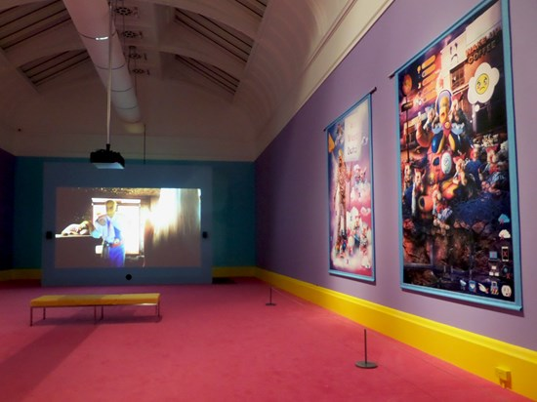

Figure 8 Rachel Maclean, WOT U :) ABOUT, installation shot, 2016, Tate Britain

The publics view on contemporary art is always conflicted, with the most famous artists being known for reasons such as successfully creating shock value, for a bold political stance, or simply for producing something that the art world has yet to have seen. This means that a general understanding of art history and context is needed when viewing what the general public most commonly sees. The power to create change lies with those who believe that change is possible, just as the entirety of global production and cultural achievement is only attained though the collective contribution of the working class. Progressive social change will only happen when we, as a society, are able to look past smaller issues that contribute towards social injustice and accept that capitalism is designed only help the elite retain their privilege. Art can help to create positive change both within a society, and globally, by envisioning and projecting into reality new visions of the cultural & economic structures of our society’s. Whether they project dystopian predictions, create utopian environments or bring issues that have been forgotten about or brushed under the carpet into a new light. Despite their being many challenges to encouraging the working class to reclaim the gallery spaces for themselves and to reject the concept of it being an intimidating space only meant for those who ultimately can afford to purchase the works. They also need to begin to feel comfortable with is the idea that it’s okay to not understand some of the work, and feel comfortable with pondering different possible meanings for one given piece. Many artists like the ones mentioned attempt to create empowerment through different means. Some choose to utilise activist actions, community based projects or work through more common mediums such as painting, video and sculpture. I don’t believe that any one medium is inherently more successful at engaging the public, just that there are different obstacles and requirements that determine whether a work is successful at the point of access. Unlike other art industries such as Music and Film, the internet has yet to revolutionise the way the public consume Art, or significantly affected artists ability to distribute their work. It is interesting to think what effect the ability of artists to digitally distribute infinite copies of an art piece globally for little to no cost might have on the art scene, and the world at large.

Bibliography

- Allen, E. (2011) Curry up! Available at: http://www.artnews.com/2012/03/13/curry-up/

- Bishop, C. (2001): Anatagonism and Relational Aesthetics. Available as PDF at: http://www.teamgal.com/production/1701/SS04October.pdf

- Bishop, C. (2006): The Social Turn: Collaboration and Its Discontents, Artforum. British Art Show 8 (no date) Available at: http://britishartshow8.com/artists/rachel-maclean-1509

- Foodbank use remains at record high (2016) Available at: https://www.trusselltrust.org/2016/04/15/foodbank-use-remains-record-high/

- Heidenreich, S. (2001) Santiago Sierra. Available at: https://frieze.com/article/santiago-sierra

- here, S. and news (2015) None of this is real. Available at: http://www.thewhitereview.org/art/none-of-this-is-real/

- Hylton, R. (1996) Imagined Communities Imagined Communities, I said, I am that I am. I am. I am. I am. National Touring Exhibitions Publisher.

- Minton, A. (2009) Ground control: Fear and happiness in the twenty-first-century city. New York: Viking Penguin.

- Ness, I. and Azzellini, D. (2011) Ours to master and to own: Workers’ control from the commune to the present. Chicago, IL: Haymarket Books.

- TED (2016) The Urgency of Intersectionality | Kimberlé Crenshaw. Available at: https://www.youtube.com/watch?v=akOe5-UsQ2o

- Tate annual report 2014-15 (2015) Available at: http://www.tate.org.uk/about/press-office/press-releases/tate-annual-report-2014-15

- Todd, S. (2014) The people: The rise and fall of the working class, 1910-2010. London, United Kingdom: John Murray Publishers.

- Thompson, J. (2016) The most expensive art bought and sold in London. Available at: http://www.standard.co.uk/goingout/arts/the-most-expensive-art-bought-and-sold-in-london-a3373426.html

- Tressell, R. (2005) The Ragged Trousered Philanthropists. Edited by Peter Miles. New York: Oxford University Press.

- Perry, G. (2013) Playing to the Gallery- Democracy Has Bad Taste. Reith Lectures- Tate Modern. BBC Radio

- PRO, R.M. (2017) Please, sir... (2014) single screen short edit from split-screen video. Available at: https://vimeo.com/125449791

- Rachel Maclean: Wot U:-) about? (2016) Available at: http://becauselondon.com/culture/2016/11/rachel-maclean-wot-u-about/

- Rirkrit Tiravanija’s ‘FEAR EATS THE SOUL’ at Gavin Brown’s enterprise, New York (2011) Available at: http://www.art-agenda.com/reviews/rirkrit-tiravanija%E2%80%99s-%E2%80%9Cfear-eats-the-soul%E2%80%9D-at-gavin-brown%E2%80%99s-enterprise-new-york/

- Quarterly, S.A. (2015) Interview Rirkrit Tiravanija. Available at: http://www.spikeartmagazine.com/en/articles/interview-rirkrit-tiravanija

This definition is obviously somewhat simplistic, as it does not take full account of the debate around class definitions. For instance, is the retired factory worker living on a modest pension, which gets its funds from a portfolio of stocks, shares and other securities, working class? There has been much debate in academia around this and the role of children and the unemployed in the class structure but for our purposes here it will suffice.

